**Spring REST using Spring Boot 3**

**Hands on 2**

**Spring Core – Load SimpleDateFormat from Spring Configuration XML**

**Project Structure**

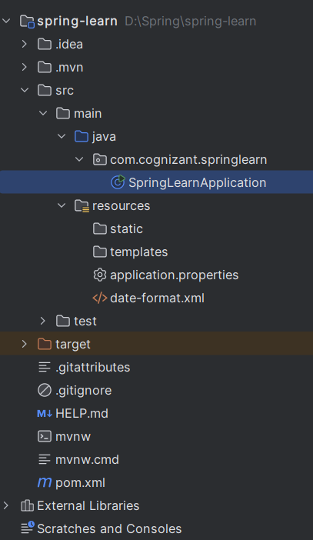

***Code Snippets***

1. SpringLearnApplication.java

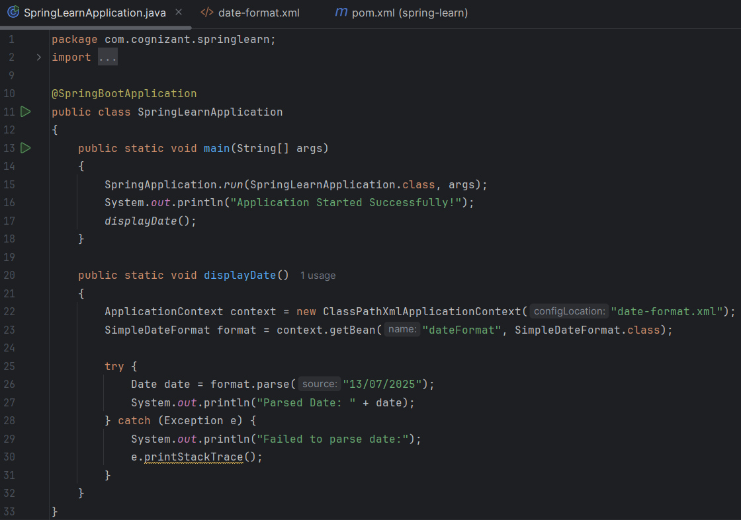

1. date-format.xml

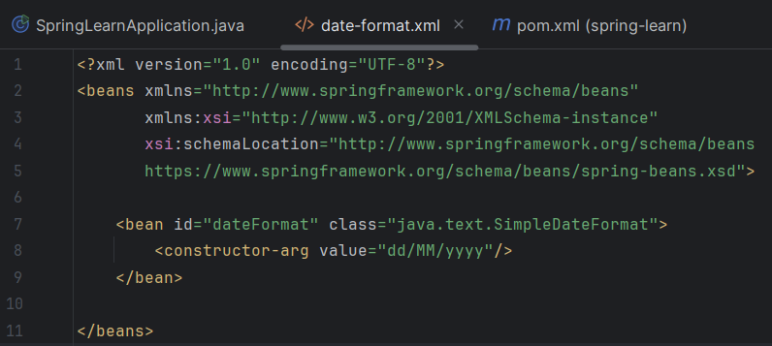

1. pom.xml

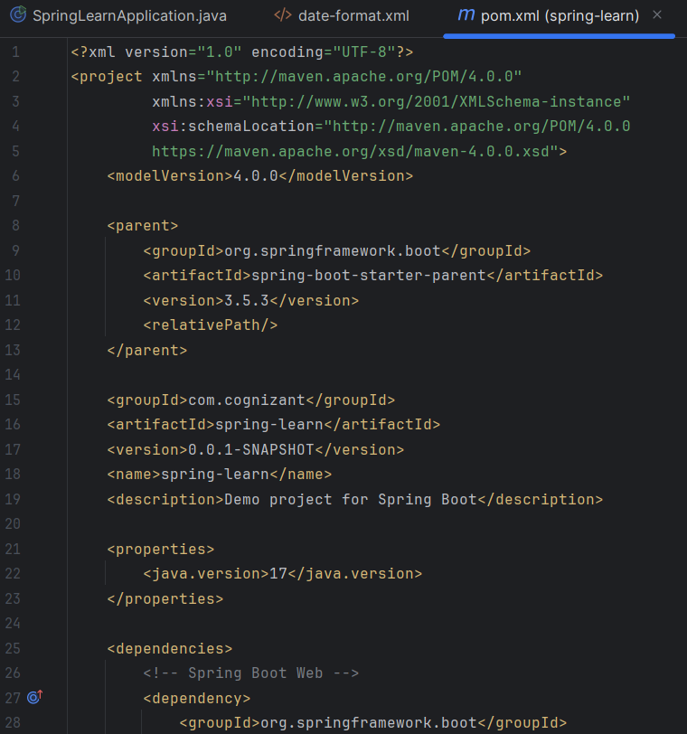

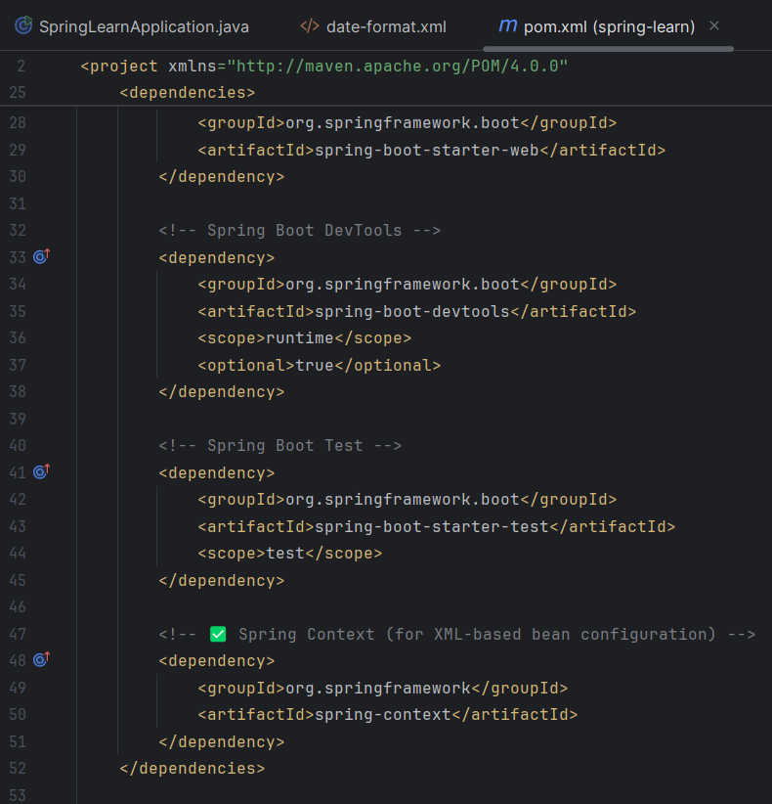

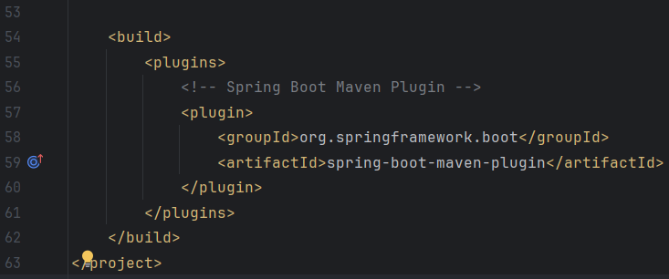

***Output Screenshot***

